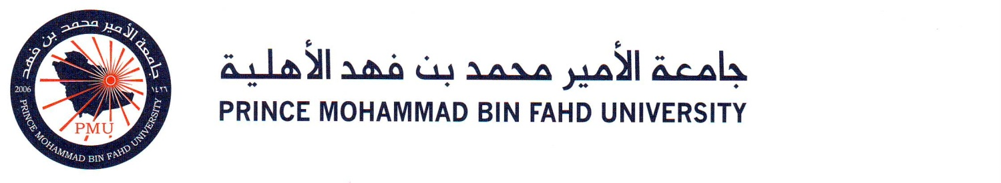

ASSE 2111: Learning Outcome Assessment 1

Assignment: Teamwork Competency

Student Name: Nasser Alghadeeri

Student ID: 202201322

LAB Section: 135
Semester and Year: Fall 2025/2026

Teamwork Definition:
Teamwork is the collaborative process in which individuals with different skills, perspectives, and responsibilities work together toward a shared goal. Effective teamwork requires clear communication, mutual respect, and accountability for individual contributions to support overall success. It involves coordinating efforts, resolving conflicts constructively, and making joint decisions that reflect the interests of the entire group. Team members contribute their strengths, help one another overcome weaknesses, and create an environment that encourages trust and commitment. Through cooperation and shared responsibility, teamwork enhances productivity, improves problem-solving, and promotes learning experiences that lead to stronger outcomes than those achieved individually.

REFLECTION PARAGRAPH ON 1st ASSIGNMENT:
In the Strength-Based Leadership group presentation from the Leadership and Teamwork course, I focused on the Teamwork Competency and the indicator of success which is using effective interpersonal and group process skills. My performance level for this competency is intermediate. This assignment required identifying my own unique strengths and talents through self-reflection and assessment tools, as well as understanding how my personal values and motivations shape my leadership approach. I had to collaborate closely with my group to complete the project and prepare a clear presentation on how strengths-based leadership improves team performance.

During this assignment, I learned how important it is to recognize individual abilities within the group in order to divide tasks effectively. Working in a team allowed me to practice communication skills, active listening, and the willingness to support others while also taking responsibility for my own part. A major benefit of this assignment was gaining confidence to speak up and share ideas that contributed to the overall success of the presentation. The experience strengthened my understanding that leadership does not always mean taking charge, but can also mean encouraging teammates to use their strengths to achieve a shared goal.

The biggest obstacle I faced in this assignment was gathering all group members at the same time to work on our material. Everyone had different schedules, which made coordination difficult. To overcome this, we focused on smart and effective time management by using online communication tools and dividing tasks so each member could complete his part individually before we met to combine everything. I believe I performed at the intermediate level because I demonstrated good teamwork, communication, and contribution, although I still need to improve my confidence in leading discussions and making quicker decisions. This assignment helped me understand that teamwork requires patience, flexibility, and appreciation of everyone’s strengths in order to succeed.

REFLECTION PARAGRAPH ON 2nd ASSIGNMENT:
In the Intercultural Roommate Conflict group presentation from the Oral Communication course, the focus was again on the Teamwork Competency and the indicator of success which is using effective interpersonal and group process skills. I evaluated my performance level as intermediate. This assignment discussed a conflict scenario between three roommates from Saudi Arabia, Japan, and the United States who struggled with their different cultural values and beliefs. As a group, we analyzed the misunderstanding and developed a solution by applying teamwork, respect, and communication strategies.

Through this assignment, I learned how teamwork plays an important role in solving conflicts, especially when cultural differences are involved. We had to work together to understand each culture’s perspective and find a fair compromise. This taught me not to judge others quickly and instead take time to listen to their reasoning. The assignment also improved my skills in public speaking, responsibility sharing, and communicating clearly with teammates while preparing for the presentation. It demonstrated that effective teamwork requires open-mindedness and proper conflict-resolution techniques.

The main obstacle we faced was finding a suitable time to gather the entire group and complete our tasks. Coordinating schedules was stressful, but we overcame this challenge through smart planning, dividing responsibilities, and communicating regularly so that each member finished their work on time. I believe my performance was at an intermediate level because I contributed well and supported my teammates, although I still want to grow in expressing my ideas more confidently and taking more initiative during group decisions. This assignment helped me understand that teamwork is essential when dealing with different viewpoints and that successful conflict resolution depends on mutual respect, cooperation, and strong communication among all team members.

